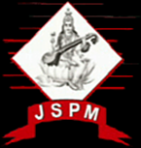 | JSPM’s  RAJARSHI SHAHU COLLEGE OF ENGINEERING  TATHAWADE, PUNE-33  (An Autonomous Institute Affiliated to Savitribai Phule Pune University, Pune) | 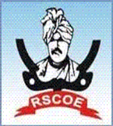

- Statement of Clear Goal, Use of appropriate methods, Significance of results, Effective presentation

Name of the Course: Mobile Computing
Name of the Faculty: Prof. Apoorva Kulkarni
Name of the Innovative Method used: Role Play Activity
Name of the topic: PCS Architecture and Applications

Statement of Clear Goal: To help students understand topics better by using Role Play Activity in teaching, so they can review difficult concepts, and enjoy learning through teaching their colleagues. It promotes active learning and collaboration while building upon fundamental architecture ideas.

Significance of result: The role play activity enriched students conceptual knowledge by converting theoretical concepts into live interactions. It encouraged participation, enhanced retention of intricate subjects and collaborative skills among students..

Effective Presentation (Screenshot):
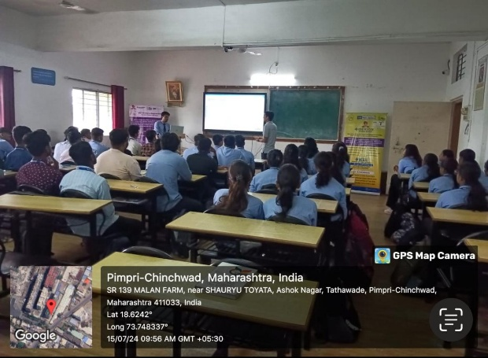

Peer Review and Critique (Feedback):
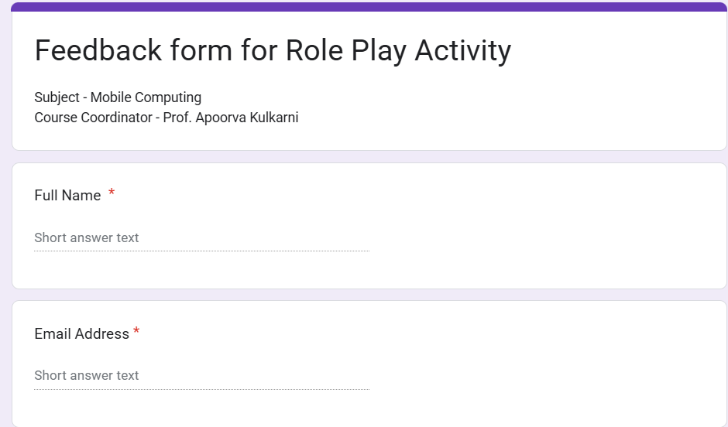

B. Availability of work related to Innovation by Faculty in Teaching and Learning is on Institute website.

https://www.jspmrscoe.edu.in/information-technology/innovation-practices

C. Availability of work for peer review and critique.

https://github.com/jspmIt/ASK

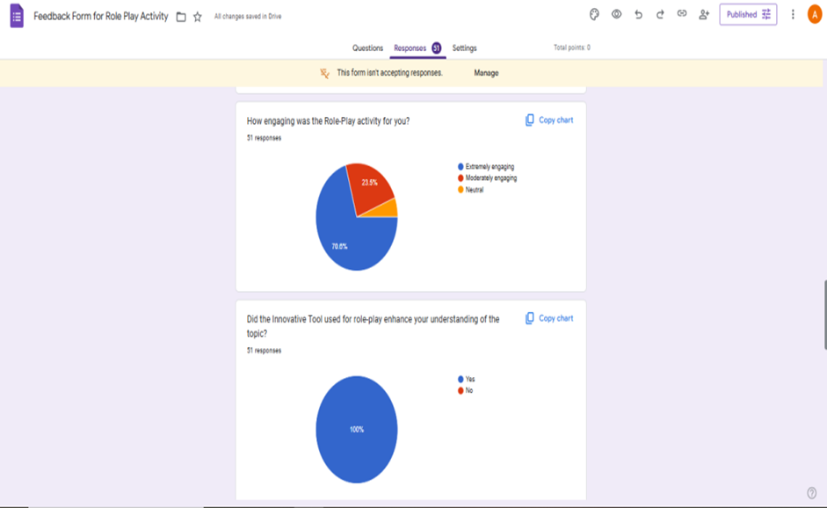

D: Reproducibility and Reusability by other scholars for further development

- Role play helps simplify abstract concepts in Mobile Computing through experiential learning.
- When properly planned and documented, such sessions can be easily replicated by other instructors.
- These pedagogies become reusable resources for presenting complex technical topics in an interesting manner.
- Sharing these innovations through academic platforms promotes peer adoption and modification.
- It creates a culture of collaborative improvement in teaching practices within institutions.
- Enables scalability of innovative approaches for use in workshops, FDP’s, and other subjects/topics.

Course Co-ordinator Module Co-ordinator HOD

Prof. Apoorva Kulkarni Dr. S.M. Chaware Dr. Nihar M. Ranjan

